Pratical-2 : Linear and Binary Search: Iterative and Recursive Approaches
Practical Aim
To implement linear and binary search using both iterative and recursive approaches.
Problem 1
Problem Statement
A security guard at a parking lot checks vehicles one by one from the entrance to find a car with a specific license plate. Sometimes he starts from the entrance, sometimes he calls a helper who starts from where the guard left off. Given a list of license plates and a target plate, implement both approaches—one that checks plates one by one from the start, and one where the function calls itself to continue checking—and report the position of the target plate found.
Describe the approach you used. What happens in your solution if the target plate appears more than once in the list? Does it find the first occurrence, the last, or just any one?
Code
#include <iostream>
#include <vector>
#include <string>

using namespace std;

int main()
{
vector<string> plate_no;
string element;
string target;
int found = 0, i1;

cout << "Enter 4 license plates: ";
for (int i = 0; i < 4; i++)
{
cin >> element;
plate_no.push_back(element);
}

cout << "Enter target plate: ";
cin >> target;

for (int i = 0; i < 4; i++)
{
if (target == plate_no[i])
{
i1 = i;
found = 1;
break;
}
}

if (found == 1)
{
cout << "Plate found: " << plate_no[i1] << endl;
cout << "Index: " << i1 << endl;
}
else
{
cout << "Plate not found." << endl;
}

return 0;
}

Output
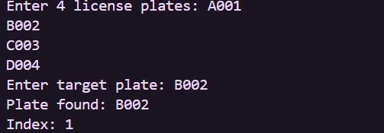
Problem 2
Problem Statement
A librarian maintains a sorted catalog of book codes and needs to locate a specific code quickly. Instead of going through every book, she opens the catalog to the middle, checks whether the target is to the left or right, and repeats. Given a sorted list of book codes and a target code, implement both approaches—one using a loop and one where the function calls itself—and report the position of the target code.
Describe the approach you used. What is the one condition your input must satisfy for this approach to work correctly? What would go wrong if that condition was not met?

Code
#include <iostream>
using namespace std;

int Binary_Search(int arr[], int n, int target, int l, int h)
{
while (l <= h)
{
int mid = (l + h) / 2;

if (arr[mid] == target)
{
return mid;
}
else if (target > arr[mid])
{
l = mid + 1;
}
else
{
h = mid - 1;
}
}
return -1;
}

int main()
{
int n;
int target;

cout << "Enter the size: ";
cin >> n;

int arr[n];

cout << "Enter sorted Book IDs: ";
for (int i = 0; i < n; i++)
{
cin >> arr[i];
}

cout << "Enter target Book ID: ";
cin >> target;

int result = Binary_Search(arr, n, target, 0, n - 1);

if (result != -1)
{
cout << "Book ID found at index: " << result << endl;
}
else
{
cout << "Book ID not found." << endl;
}

return 0;
}
Output
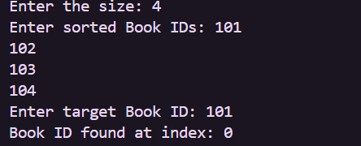
Key Questions / Analysis / Interpretation to be Evaluated During/After
Implementation
1.[Problem 1] If the target plate appears near the end of a very long list, your solution still checks every plate before it. Can you think of any property the input would need to have for you to skip checking some plates entirely? What does Problem 2.2 tell you about this?
Answer: The list must be sorted so we can skip half of the plates after each comparison.
Problem 2.2 shows that binary search works efficiently on sorted data.
2. [Problem 2] What is the consequence of applying your solution to a list that is not
sorted? Would it always give a wrong answer, or only sometimes? Explain your
reasoning without running any example.
Answer: If the list is not sorted, the solution may give a wrong answer because binary search depends on sorting. It will work correctly only when the required ordering is maintained.
Conclusion:
• Understood linear and binary search.
• Implemented iterative and recursive methods.
• Compared search techniques.
• Verified outputs with test cases.
• Improved problem-solving skills.

